* **Name :-** SHAIL KUMARI
* **Registration No. :-** ADIT22AP05231
* **Nsti :**- Kanpur
* **Task :-** Create a marksheet with data validation.
* **Hardware :-** Desktop
* **Software :-** MS EXCEL

**Steps to create a marksheet with data validation**

1. *Open MS office excel*
2. *After that create a marksheet for several student and write roll no., student name, subject average marks,* and at last result***.***
3. *Then After give the marks to the student for each subject.*
4. *After giving the marks we have to calculate the total no. of each students*
5. *To find sun syntax (=sum) and select the cell which we need sum.*
6. *For calculating percentage you click on total no. then divide by the total no. of subjects*
7. 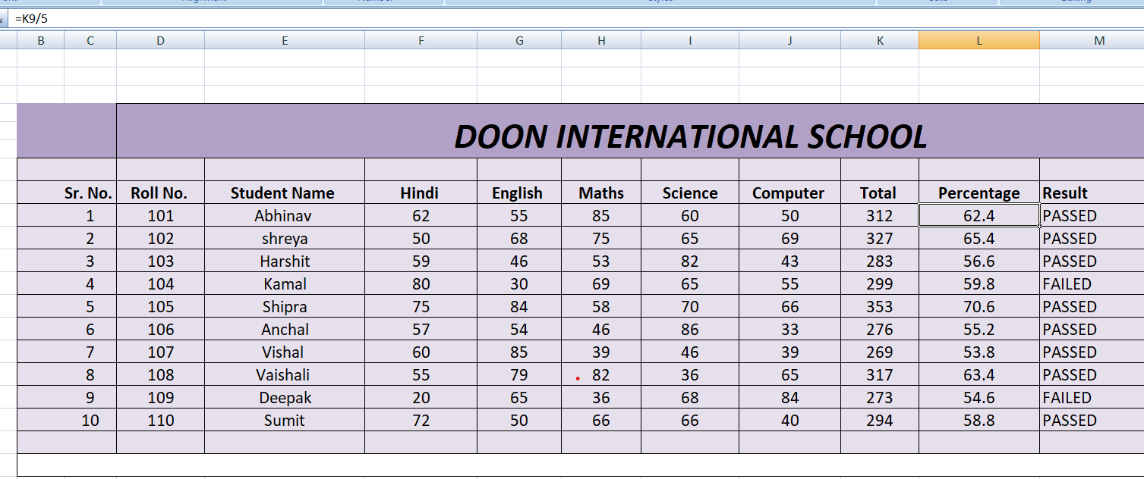
8. After this result is shown is the student passed or failed so for this we have to apply formula
9. = if (and(f9>=33,G9>=33,H9>=33,I9>=33,j9>=33), “PASSED”, “FAILED”).

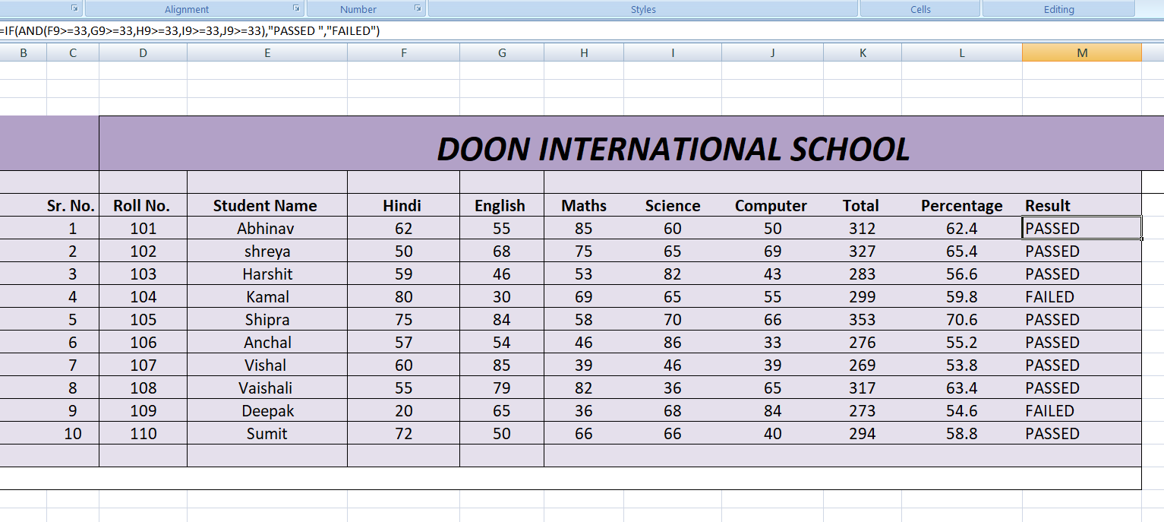

**ACTIVITY -02**

**Task – Create bootable pendrive via cmd**

1. *Insert a USB flash drive into a running computer*
2. *Open a command prompt window as an administrator*
3. *Type – diskpart*
4. *list disk*
5. *select disk*
6. *Clean*
7. *Create partition primary*
8. *Select partition 1*
9. *Format Fs = ntfs quick*
10. *Active*
11. Exit

**Activity -03**

**Task – Crimp a straight through cable (T568A)**

**List of hardware/software required :**

1. ***Ethernet cable***
2. ***Crimping tool***

**STEPS :-**

1. Making a straight through cable.
2. Cable inspection.
3. Stripping the cable.
4. Putting the wires in the connectors.
5. Crimping the connectors
6. Use colour cable coding ( g G o B b O br Br (t568A) )
7. Use colour cable coding (( g G o B b O br Br (t568A) )
8. Now Test the cables.

